**Insert School Logo**

**Semester Two**

**Examination 2021**

**Question/Answer booklet**

**MATHEMATICS**

**METHODS UNITS 3 & 4**

**Section Two:**

**Calculator–assumed**

|  |
| --- |
| Student Name: _____________________________________ |
| Teacher’s Name: _____________________________________ |

**Time allowed for this section**

Reading time before commencing work: ten minutes

Working time for paper: one hundred minutes

**Material required/recommended for this section**

**To be provided by the supervisor**

This Question/Answer booklet

Formula Sheet (retained from Section One)

**To be provided by the candidate**

Standard items: pens (blue/black preferred), pencils (including coloured), sharpener, correction tape/fluid, erasers, ruler, highlighters

Special Items: drawing instruments, templates, notes on two unfolded sheets of A4 paper, and up to three calculators approved for use in the WACE examinations.

**Important note to candidates**

No other items may be taken into the examination room. It is **your** responsibility to ensure that you do not have any unauthorised notes or other items of a non–personal nature in the examination room. If you have any unauthorised material with you, hand it to the supervisor **before** reading any further.

**Structure of this paper**

|  |  |  |  |  |  |
| --- | --- | --- | --- | --- | --- |
|  | Number of questions available | Number of questions to be attempted | Working time (minutes) | Marks available | Percentage of exam |
| Section One  Calculator—free | 10 | 10 | 50 | 50 | 35 |
| **Section Two**  **Calculator—assumed** | **12** | **12** | **100** | **100** | **65** |
|  | | | | 150 | 100 |

**Instructions to candidates**

1. The rules for the conduct of Western Australian external examinations are detailed in the

*Year 12 Information Handbook 2021.* Sitting this examination implies that you agree to abide by these rules.

1. Answer the questions according to the following instructions.

**Show all your working clearly.** Your working should be in sufficient detail to allow your

answers to be checked readily and for marks to be awarded for reasoning. Incorrect answers given without supporting reasoning cannot be allocated any marks. For any question or part question worth more than two marks, valid working or justification is required to receive full marks. If you repeat an answer to any question, ensure that you cancel the answer you do not wish to have marked.

It is recommended that you **do not use pencil**, except in diagrams.

1. You must be careful to confine your responses to the specific questions asked and to follow any instructions that are specific to a particular question.
2. Spare pages are included at the end of this booklet. They can be used for planning your responses and/or as additional space if required to continue an answer.

* Planning: If you use the spare pages for planning, indicate this clearly at the top of the page.
* Continuing an answer: If you need to use the space to continue an answer, indicate in the original answer space where the answer is continued, i.e. give the page number. Fill in the number of the question that you are continuing to answer at the top of the page.

1. The Formula Sheet is **not** handed in with your Question/Answer Booklet.

# Section Two: Calculator–assumed 65% (100 marks)

This section has **twelve (12)** questions. Attempt **all** questions. Write your answers in the spaces

provided.

Spare pages are included at the end of this booklet. They can be used for planning your responses

and/or as additional space if required to continue an answer.

* Planning: If you use the spare pages for planning, indicate this clearly at the top of the page.
* Continuing an answer: If you need to use the space to continue an answer, indicate in the original answer space where the answer is continued, i.e. give the page number. Fill in the number of the question(s) that you are continuing to answer at the top of the page.

Working time: 100 minutes

**Question 11 (4 marks)**

A diamond mining company has its marginal cost, *Mc*, and marginal revenue, *Mr*, functions

in millions of dollars such that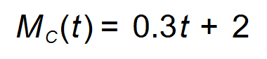 and 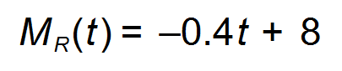 where *t* is the

time in years. The initial establishment costs amounted to $12 million.

(a) Determine the length of time the company should continue mining until the profit is at a maximum. (2 marks)

(b) Evaluate the maximum profit. (2 marks)

**Question 12 (11 marks)**

(a) An RBT roadblock is set up by the police to check if drivers are under the blood alcohol limit.

Explain why this can be considered a Bernoulli trial. (2 marks)

(b) It has been determined that 5% of drivers checked at a certain roadblock are over the blood alcohol limit and 1.3% of drivers checked do not wear seat belts. It has also been observed that the two infractions are independent of each other. A police officer stops 10 drivers at random.

(i) Calculate the probability that exactly three of the drivers are over the blood alcohol

limit or do not wear seat belts. (Hint: Let *X* be the RV drivers over the blood alcohol limit; Let *Y* be the RV drivers do not wear seat belts.) (3 marks)

(ii) Calculate the probability that at least one of the drivers checked does not wear seat belts. (1 mark)

(iii) If 275 drivers are checked, calculate the number of expected drivers over the blood

alcohol limit and the associated standard deviation. (2 marks)

(iv) Another random sample of drivers is selected where the random variable *Y*

is the number of drivers who do not wear seat belts. Find the maximum value

of *n* such that the probability that there is at least one driver not wearing a

seat belt is no more than 60%. (3 marks)

**Question 13 (4 marks)**

Two curves with equations 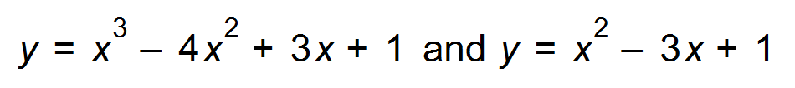intersect as

shown below. The line passing through the points of intersection of the curves has

the equation 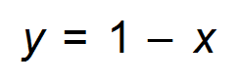.

Determine the fraction of the shaded area which lies below the line. (4 marks)

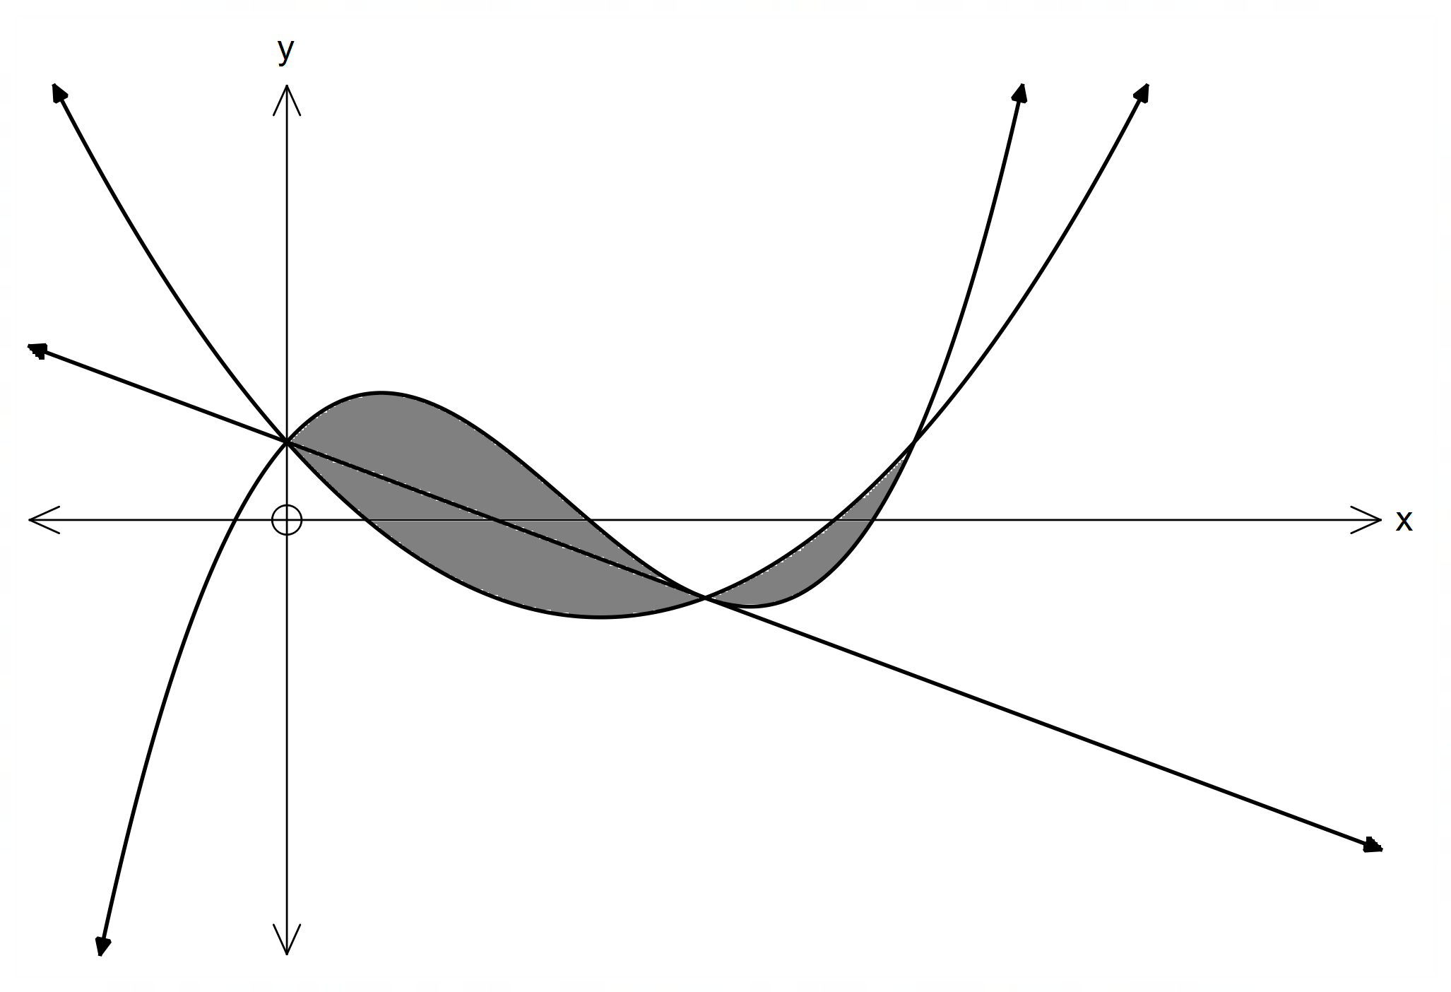

**Question 14 (11 marks)**

A right circular cone with radius *p* and height *t* is machined (cut out) from a solid sphere (with centre C) with a radius of 30 cm as shown in the sketch.

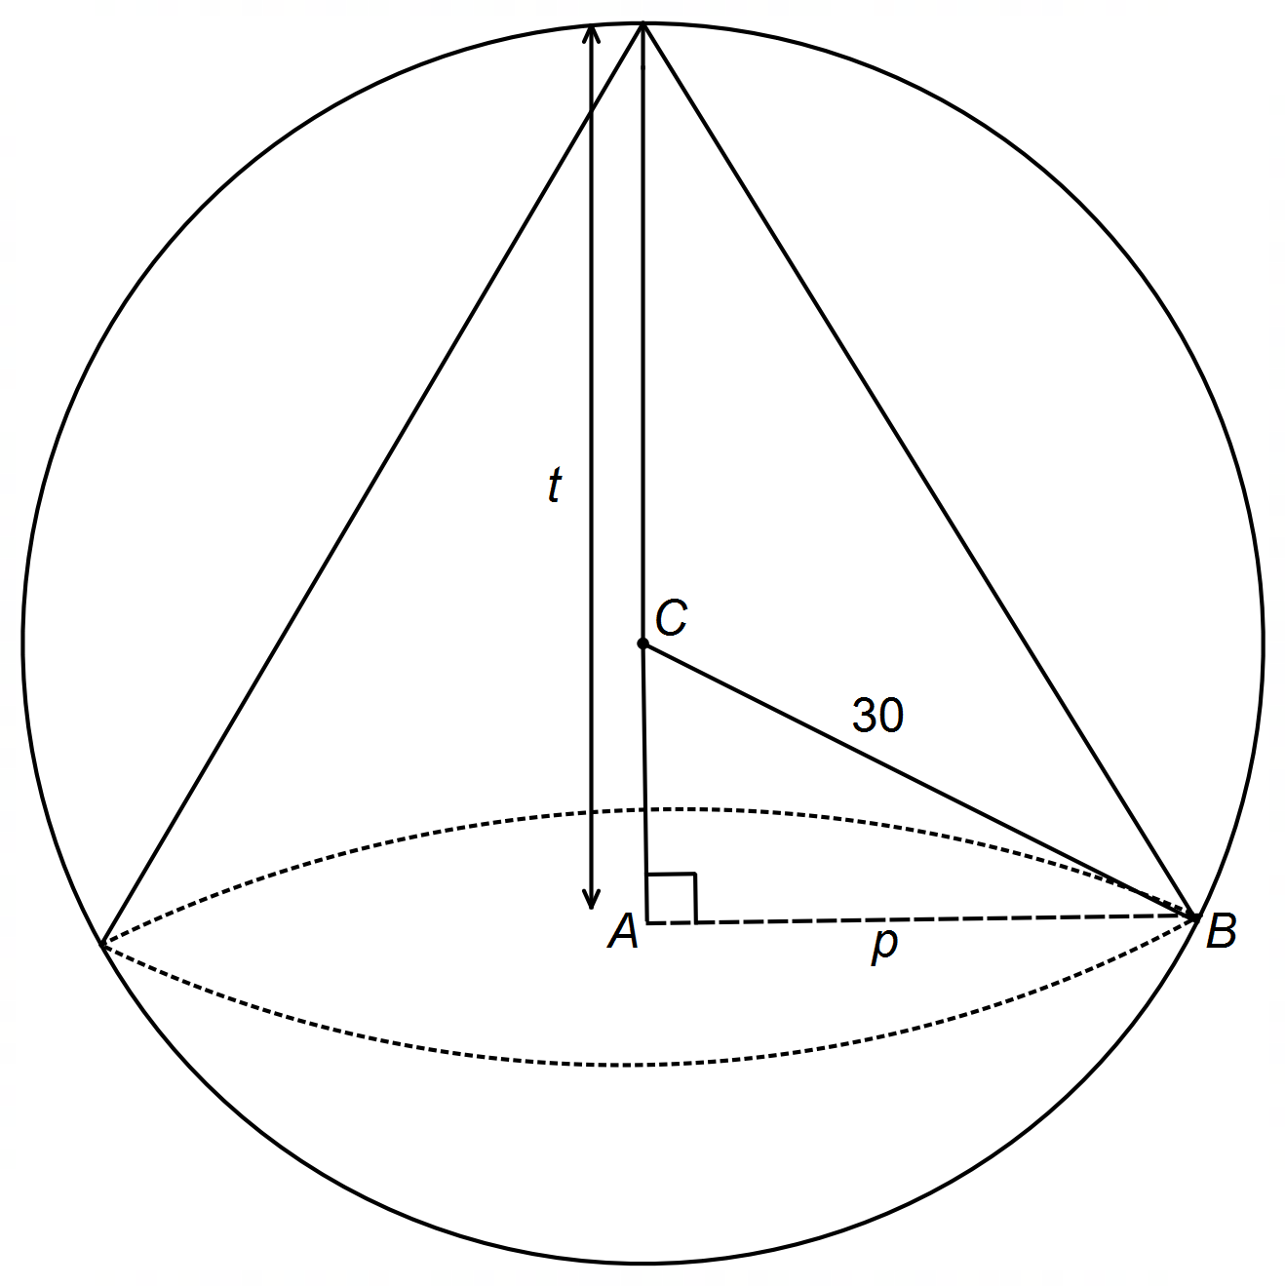

(a) Show that the volume of the cone can be written as 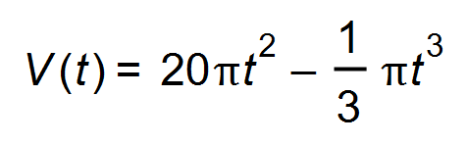. (3 marks)

(b) Use calculus methods to determine the value of *t* for which the volume of the

cone will be a maximum. (3 marks)

(Question 14 continued)

(c) What percentage of the sphere was used to obtain this cone having the maximum volume? (2 marks)

(d) If the radius of the sphere decreases by 1.5%, use the incremental formula to find the corresponding percentage decrease in the volume of the sphere. (3 marks)

**Question 15 (8 marks)**

A supermarket has been investigating how long customers have to wait at the checkout. During any half hour period, the percentage *P* %, of customers who wait for less than *t* minutes, can be modelled by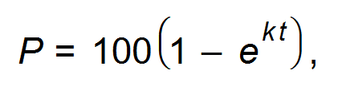 where *k* is a constant.

(a) If 50% of customers wait for less than 3 minutes, show that the value of 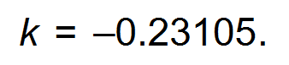

(1 mark)

(b) Calculate the percentage of customers who wait for 5 minutes or longer. (2 marks)

Sachi, a Year 12 Mathematics Methods student, decides to divide this function by 100 and then

model the waiting time as a cumulative probability density function.

(c) (i) Justify this student’s decision for the 30 minute domain given. (2 marks)

(ii) Show, using the cumulative probability density function, that the probability

of waiting for less than a quarter of an hour is approximately 0.97. (1 mark)

(iii) Determine the probability of a customer waiting for less than 5 minutes

given they have waited for less than 10 minutes. (2 marks)

**Question 16 (4 marks)**

A beaker of liquid was placed in a fridge. The rate of cooling was given by 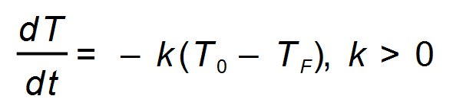 where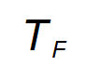 is the constant temperature in the fridge,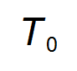is the starting temperature and *T* is the temperature of the liquid at time *t* (minutes).

* The constant temperature in the fridge is 4°C.
* When first placed in the fridge, the temperature of the liquid was 25°C.
* At 12 noon, the temperature of the liquid was 9.8°C.
* At 12:15 pm, the temperature of the liquid had dropped to 6.5°C.

Therefore, given that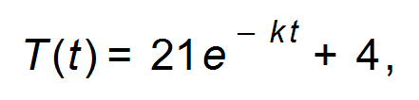determine at what time, to the nearest

minute, the liquid was placed in the fridge. (4 marks)

**Question 17 (14 marks)**

A plantation of a certain type of tree is planted for the Australian forest and wood industry.

The height (*h* cm) of this certain tree at time *t* years is modelled by the equation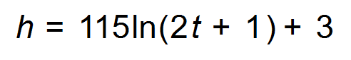.

(a) How many times faster (to 1 decimal place) is a six-year old tree growing

than a 50-year-old tree? (2 marks)

(b) (i) An area of the plantation contains only six-year old trees.

A sample of these six-year old trees is measured. A forest ranger parks his

car at the side of the road and measures the heights of the closest 25 trees.

Explain the bias in this sample. (2 marks)

(ii) Describe a sampling technique which could be used to minimise bias. (2 marks)

(c) (i) A fair sample of these six−year old trees are measured.

The heights are normally distributed with a mean of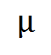cm and a

standard deviation of 12 cm. It is found that 0.94% of the trees

have a height over 326 cm. Find the value of the mean. (3 marks)

(ii) Hence, or otherwise, comment on the suitability of the equation modelling

the height of the trees. (1 mark)

(iii) Five trees from the sample appear to have a fungus disease.

Find the probability that none of them are over 326 cm. (1 mark)

(Question 17 continued)

(d) From a random sample of 400 mature trees, 132 can be felled to produce

luxury furniture. Find a 99% confidence interval for the proportion of **all** the

mature trees which can be felled to produce luxury furniture and interpret

the interval in this context. (3 marks)

**Question 18 (3 marks)**

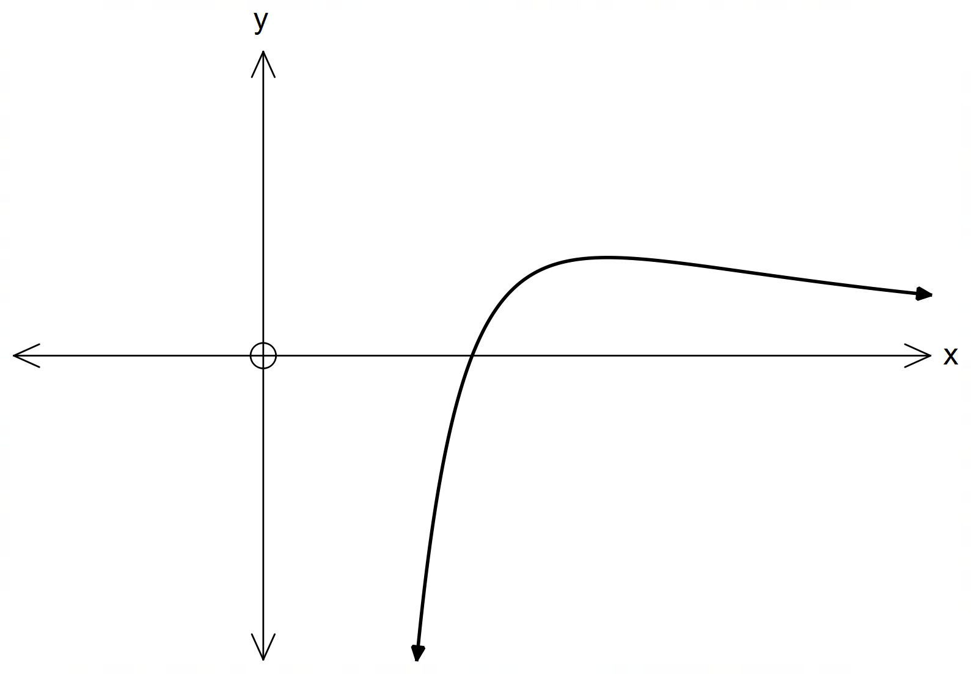The function 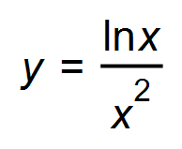 is shown below.

Given the following ordered pairs, approximate the area under the curve from

*x* = 1 to *x* = 2 using the average of circumscribed and inscribed rectangles.

|  |  |  |  |  |  |  |
| --- | --- | --- | --- | --- | --- | --- |
| *x* | 1 | 1.2 | 1.4 | 1.6 | 1.8 | 2 |
| y | 0 | 0.127 | 0.172 | 0.184 | 0.181 | 0.173 |

**Question 19 (12 marks)**

(a) In the aftermath of the COVID pandemic, 12% of the workforce are unemployed.

300 people are selected at random and surveyed.

(i) Explain how a normal distribution can be approximated for the sample proportion distribution. (2 marks)

(ii) State the parameters of the distribution. (2 marks)

(iii) Determine the probability that more than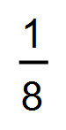of the people surveyed

are unemployed. (1 mark)

(iv) Determine the percentage of people surveyed who would be in the

lower quartile of the distribution. (2 marks)

(b) The waiting time for an appointment with an employment agent is uniformly

distributed over the interval 5 to 20 days. The waiting time of several samples

of forty job seekers were recorded.

(i) Find the probability that a randomly chosen job seeker has to wait at the

most 18 days to get an appointment. (1 mark)

(ii) Find the expected waiting time and describe the probability distribution

of the sample proportion of forty job seekers with waiting times exceeding

the expected waiting time. (3 marks)

(iii) Find the probability that a randomly chosen sample has a sample

proportion of job seekers with waiting time exceeding the expected

waiting time of no more than 70%.

(1 mark)

**Question 20 (7 marks)**

(a) Show clearly that the derivative of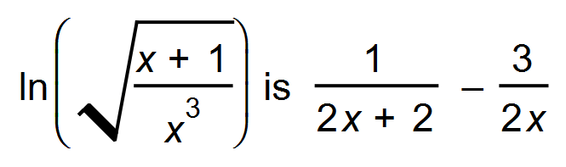. (3 marks)

(b) The *pH* scale measures the acidity of a solution. The *pH* value (hydrogen potential) is given by

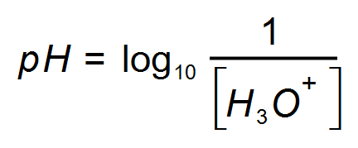 where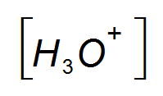 is the hydronium ion concentration in moles per litre.

Most foods are acidic which means they have a *pH* < 7.

(i) The *pH* of bananas ranges from 4.5 to 4.7.

Show, by using exponential equations, that the corresponding bounds

for range from approximately 0.00003 to 0.00002 moles per litre. (2 marks)

(ii) The cerebrospinal fluid in the brain has a hydronium ion content of

about 4.8 x 10-8 moles per litre. Determine whether or not brain fluid is

acidic and state its *pH.* (2 marks)

**Question 21 (10 marks)**

A nutritionist found that in a random sample of 80 students, 28 students indicated

that they had not eaten breakfast before going to school.

(a) Find the point estimate for the population proportion of students who have not

eaten breakfast before going to school. (1 mark)

(b) (i) Calculate a 95% confidence interval of the true proportion of students

who do not eat breakfast before going to school. (2 marks)

(ii) Determine the margin of error for the above interval. (1 mark)

(iii) If the confidence interval increases to a 99% level, show that the interval

width increases by 31.45%. (2 marks)

(c) Determine the sample size required to achieve a margin of error of 2%

in an approximate 95% confidence interval for the proportion of students

who go to school without eating breakfast. (3 marks)

(d) The nutritionist collects a further forty samples and finds 95% confidence intervals

for each sample proportion. How many of these intervals would contain the true

proportion of students who do not eat breakfast before going to school? (1 mark)

**Question 22 (12 marks)**

When *t* = 0, a particle travelling in a straight line with a velocity of 20 units/sec, is 12 units to the right of the origin. The acceleration of the particle is given by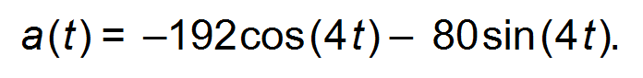

(a) Determine the maximum velocity of the particle. (3 marks)

(b) Determine whether the particle is increasing or decreasing its speed

at *t* = 2 seconds. (3 marks)

(c) Determine the displacement of the particle at *t* = 2 seconds. (2 marks)

(d) Determine the net change in displacement during the fifth second. (2 marks)

(e) Determine the total distance the particle has travelled in the first 5 seconds. (2 marks)

End of Questions

**Additional working space**

Question number(s): ……………………

**Additional working space**

Question number(s): ……………………